Pizza Sales Report
SQL Data Validation
--1. Total Revenue:

SELECT SUM(total_price) AS total_revenue
from
pizza_orders;
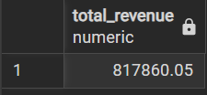
--2. Average Order Value

SELECT (SUM(total_price)/ COUNT(distinct order_id)) AS Avg_Order_Value
From
pizza_orders;
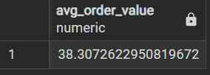
--3. Total Pizzas Sold

SELECT SUM(quantity) as Total_Pizzas_Sold FROM pizza_orders;

--4. Total Orders

SELECT count(DISTINCT order_id) AS Total_Orders FROM pizza_orders;
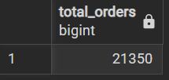
--5. Average Pizzas Per Order
--first way
SELECT
ROUND(SUM(quantity)::numeric / COUNT(DISTINCT order_id), 2)
AS avg_pizzas_per_order
FROM pizza_orders;

--second way
SELECT CAST(CAST(SUM(quantity) AS DECIMAL(10,2)) /
CAST(COUNT(DISTINCT order_id) AS DECIMAL(10,2)) AS DECIMAL(10,2))
AS Avg_Pizzas_per_order
FROM pizza_orders;

--B. Daily Trend for Total Orders

SELECT
TO_CHAR(order_date, 'Dy') AS day_name,
COUNT(DISTINCT order_id) AS total_orders
FROM pizza_orders
GROUP BY day_name, EXTRACT(DOW FROM order_date)
ORDER BY EXTRACT(DOW FROM order_date);
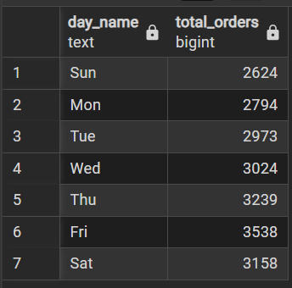
--C. Monthly Trend for Orders
SELECT
TO_CHAR(order_date, 'Mon') AS month,
COUNT(DISTINCT order_id) AS total_orders
FROM pizza_orders
GROUP BY DATE_TRUNC('month', order_date), month
ORDER BY DATE_TRUNC('month', order_date);
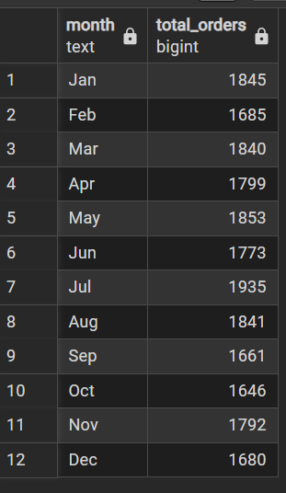
--% of Sales by Pizza Category

SELECT
pizza_category,CAST(SUM(total_price) as decimal(10,2)) as total_revenue,
ROUND(
SUM(total_price) * 100.0 / SUM(SUM(total_price)) OVER (),
2
) AS percentage_sales
FROM pizza_orders
GROUP BY pizza_category
ORDER BY percentage_sales DESC;
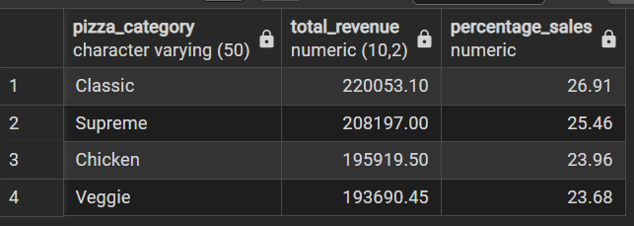
--% of Sales by Pizza Size
SELECT
pizza_size,CAST(SUM(total_price) as decimal(10,2)) as total_revenue,
ROUND(
SUM(total_price) * 100.0 / SUM(SUM(total_price)) OVER (),
2
) AS pct_sales
FROM pizza_orders
GROUP BY pizza_size
ORDER BY pct_sales DESC;
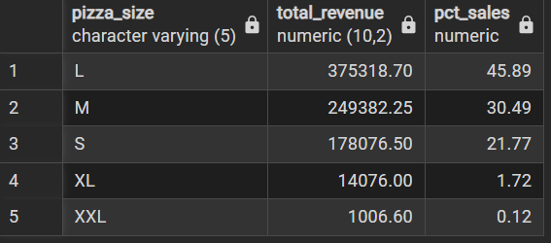
--Total Pizzas Sold by Pizza Category
SELECT pizza_category,
SUM(quantity) AS total_pizzas_sold
FROM pizza_orders
GROUP BY pizza_category
ORDER BY total_pizzas_sold DESC;
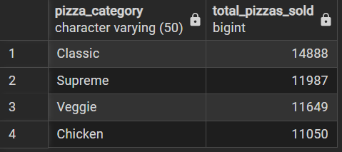
--Top 5 Pizzas by Revenue

SELECT pizza_name, SUM(total_price) AS Total_Revenue
FROM pizza_orders
GROUP BY pizza_name
ORDER BY Total_Revenue DESC
limit 5;
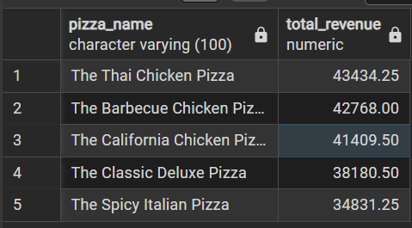
--Bottom 5 Pizzas by Revenue
SELECT pizza_name, cast(SUM(total_price) as decimal(10,2)) AS Total_Revenue
FROM pizza_orders
GROUP BY pizza_name
ORDER BY Total_Revenue ASC
limit 5;
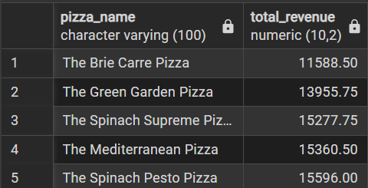
--Top 5 Pizzas by Quantity
SELECT
pizza_name,
SUM(quantity) AS total_pizza_sold
FROM pizza_orders
GROUP BY pizza_name
ORDER BY total_pizza_sold DESC
LIMIT 5;
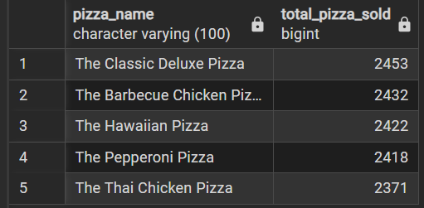
--Bottom 5 Pizzas by Quantity
SELECT
pizza_name,
SUM(quantity) AS total_pizza_sold
FROM pizza_orders
GROUP BY pizza_name
ORDER BY total_pizza_sold asc
LIMIT 5;
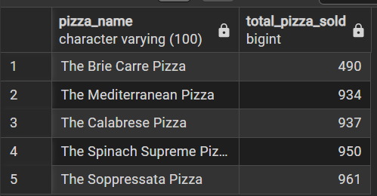
--Top 5 Pizzas by Total Orders

SELECT pizza_name, COUNT(DISTINCT order_id) AS Total_Orders
FROM pizza_orders
GROUP BY pizza_name
ORDER BY Total_Orders DESC
limit 5;
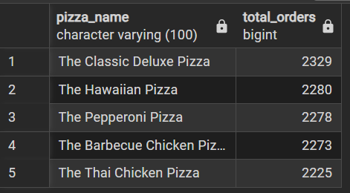
--Borrom 5 Pizzas by Total Orders

SELECT pizza_name, COUNT(DISTINCT order_id) AS Total_Orders
FROM pizza_orders
GROUP BY pizza_name
ORDER BY Total_Orders ASC
limit 5;
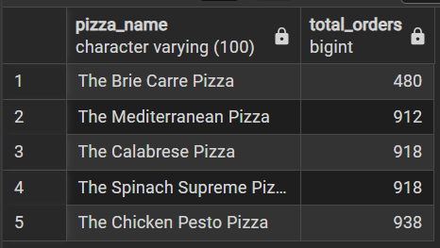
--to apply the pizza_category or pizza_size filters to the above queries you can use WHERE clause.
SELECT pizza_name, COUNT(DISTINCT order_id) AS Total_Orders
FROM pizza_orders
WHERE pizza_category = 'Classic'
GROUP BY pizza_name
ORDER BY Total_Orders ASC
limit 5;
